FIVE-YEAR
BUSINESS PLAN

Leathermarket JMB

26 Leathermarket Street, London, SE1 3HN  www.leathermarketjmb.org.uk  Tel: 020-7450-8000 |  | 

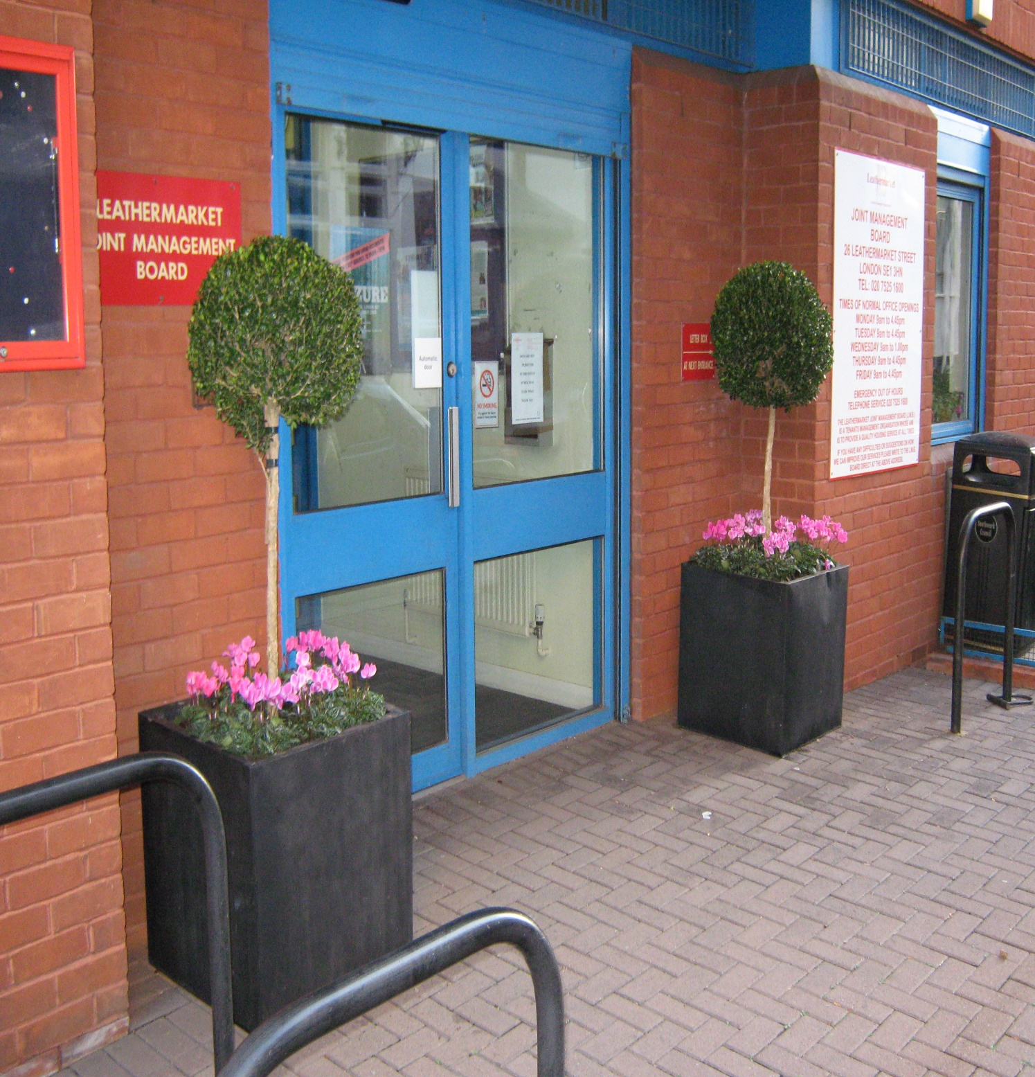

Contents
1. Business Plan 6
2. Executive summary 7
2.1. Introduction 7
2.2. Challenges 7
2.3. Solutions 7
3. Background on Business Plan 8
4. Background on the JMB 9
5. JMB vision and values 11
6. Key performance indicators 11
6.1. Top quartile performance 11
6.2. TMO & Southwark Council satisfaction levels 13
6.3. Deprivation information 13
7. Objectives 15
7.1. Top quality services 15
A. Introduction 15
B. Challenges 15
C. Providing a reliable responsive repair service 15
D. Anti-social behaviour (ASB) 16
E. Resolving problems 16
F. Maintaining a pleasant environment 16
G. Leaseholders 17
7.2. JMB members 17
A. Participatory democracy 17
B. Community cohesion 20
C. Organised compassion 20
7.3. Maintain and upgrade residents’ homes and environment 21
A. Introduction 21
B. Fire Safety 21
C. Estate Improvement Plan 22
D. Survey results 22
E. 13- Year plan 23
F. Minor estates works 25
G. Healthy homes – condensation 26
I. Major works quality 26
7.4. Meet housing need 27
A. Analysis of housing need 27
B. Community Benefit Society (CBS) 29
C. Better fit 30
D. Void turnaround times 30
E. Unlawful occupants 30
8. Building blocks 30
8.1. Governance 30
8.2. Excellent employer of excellent staff 31
A. Overview 31
B. Lean 31
C. General Data Protection Regulations (GDPR) & electronic document management 32
D. Information technology 32
8.3. Financial management 33
A. Introduction 33
B. Self-financing 33
C. Income and expenditure 34
D. Financial Planning 36
E. JMB reserves policy 36
F. Major works homeowner contributions 37
G. Challenges 37
H. Forced sale of high value voids 39
I. Increase in right to buy discount 40
J. Rent loss due to properties being empty 40
8.4. Equality 40
A. Overview 40
B. Allocations 41
C. Vulnerable residents 42
D. Decision-making 42
E. Income 42
9. Succession Planning 42
10. Resource implications 43
11. 5-year update 44
12. Key documents 45

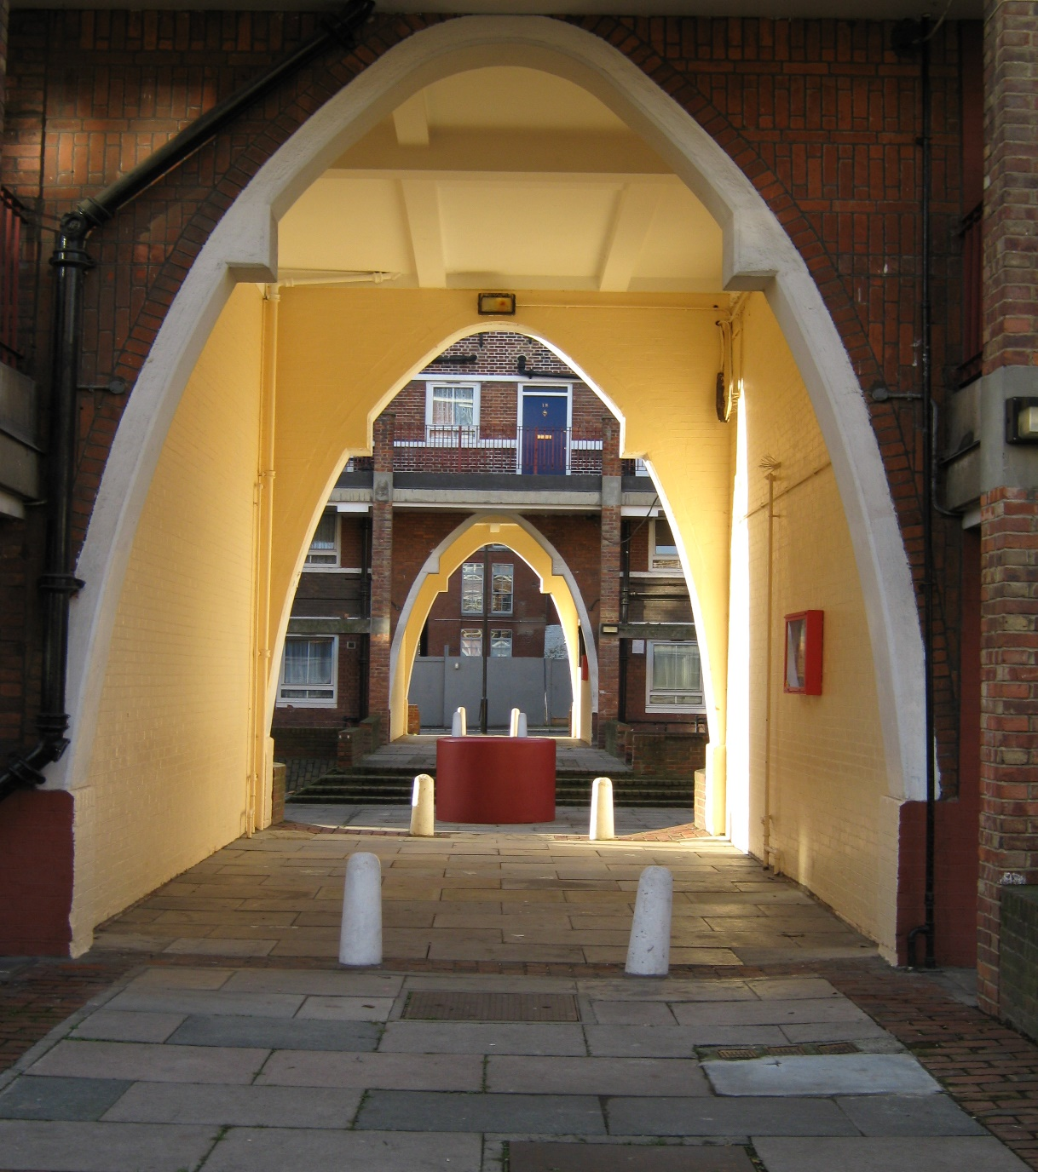

  - Leathermarket JMB Objectives:
- Top quality services
- JMB residents: participatory democracy, community cohesion, and organised compassion
- Maintain and upgrade homes, blocks, and estates
- Meet housing need: build new homes, better fit of residents to existing homes, tackle unlawful sub-letting.
  - Leathermarket JMB Building Blocks:
- Governance
- Excellent employer of excellent staff
- Financial management
- Equality.

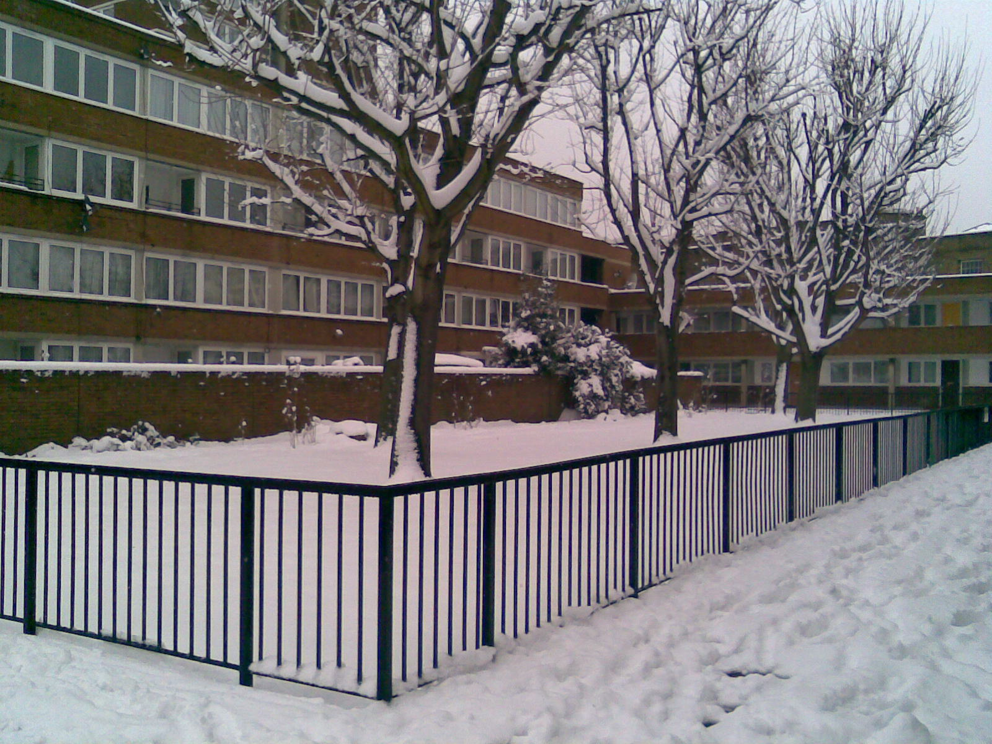

1. Business Plan
This Business Plan is a formal statement of Leathermarket JMB’s objectives and sets out its plan for how it intends to achieve them. This Business Plan ensures that the JMB has a strategic plan for the future and is prepared for the challenges ahead.

2. Executive summary

2.1. Introduction
In 2013 the JMB became self-financing when Southwark Council agreed to devolve responsibility for the JMB’s slice of the Housing Revenue Account (HRA). The JMB manages 2.5% of the borough’s housing stock, retains a commensurate amount of income, and is paying off its proportion of the debt of all Southwark properties.

2.2. Challenges
The JMB faces the same acute challenges as all other managers of council housing. The intention behind self-finance was that organisations could undertake 30-year financial and stock investment planning, rather than being dependent on an annual financial settlement with the government. The initial assurance was that self-financed organisations would be allowed the autonomy to run their own affairs, but would also accept responsibility. This turned out not to be the case. The JMB faces the same external challenges as other social housing providers, due to:
- The Government direction of rent levels; for four years, this has resulted in lower-than-anticipated rental income
- The introduction of Welfare Reform and the roll-out of Universal Credit
- The increase in the right-to-buy discount to £103,900
- The uncertainty about whether the forced sale of high value voids will be introduced
In addition, the Grenfell tower fire has concentrated everyone’s minds on the critical importance of fire safety.
The combined (adverse) effect of the factors listed above means that significant changes are required to the JMB’s financial and major works plan.
The JMB has given a commitment to its residents and the Council to invest in its stock and to ensure that its properties are safe and their long-term viability is assured. However, this can result in high major works charges for leaseholders.

2.3. Solutions
The JMB continues to believe that the right way to respond to these challenges is through high-quality, local, and personalised management. Genuine participatory democracy also ensures that residents determine the solution, rather than have it imposed upon them. For instance, for an individual leaseholder, having to pay a £20,000 major works charge is very difficult. If, however, they have been involved in the decision-making, understand why the work was necessary, help to specify the technical solution, and know that the work will be tightly managed, it will be easier to bear.
Leathermarket JMB can look to the future with confidence; over the last five years the JMB has delivered quality services and major works, and it is now building new council rent homes. In its 2016 Continuation Ballot, independently conducted by the Electoral Reform Society, the JMB received a ringing endorsement from its residents:
- 94% tenant support on a 75% ballot return
- 91% resident leaseholder support on a 53% ballot return
- 93% non-resident leaseholder support on a 48% ballot return
This was the highest approval rating the JMB has achieved in its twenty-two year history.
As noted in section 6, the JMB consistently achieves top quartile performance against the sector’s standard Key Performance Indicators.
As noted later in the Business Plan, the JMB’s long-term financial planning would significantly benefit from government confirmation that it will not be pursuing forced sales and high level voids, as well as an agreement with Southwark Council to create a level self-finance playing field, in particular allowing the JMB to access its portion of borrowing headroom.
The JMB is delighted by the consistent councillor support it has received from across the political spectrum in Southwark. The JMB is grateful for the advice and practical support provided by officers.
The JMB’s objectives and building blocks remain unchanged from its previous Business Plan, and continue to give direction to the JMB’s day-to-day activities. However, as described below, the JMB continues to innovate and strive for improvement in the way that it delivers its key objectives.

3. Background on Business Plan
In advance of self-financing in April 2013, the JMB prepared a thirty year financial plan and a thirty year major works plan, which run between April 2013 and April 2043. A key building block for the thirty year major works plan was the preparation of a comprehensive stock condition survey. This Business Plan should be read in conjunction with these documents.
Five years after the initiation of self-finance is the right time for the JMB to review its plans, because it:
- Now understands how self-finance works in reality
- Better understands the effect of significant external factors that have emerged post-self-finance i.e. Housing and Planning Act, Government rent-setting and participation in the Universal Credit pilot area
- Has concluded its Estate Improvement Plan consultation exercise, whereby residents were asked to specify their aspirations for their homes and estates
- Has just completed its 13-year major works plan, which addresses its known stock investment needs. 13 years is the time required from our current starting point to address known health and safety issues, undertake planned attribute replacement, undertake external decorations, and ensure all secure tenancies remain within the Decent Homes standard.
Before commencing self-finance, an independent consultation exercise was undertaken with residents and the four objectives set out on page 4 were affirmed as the correct focus for the JMB in the forthcoming years. The board then agreed on the JMB’s four building blocks. As noted above, these four objectives and four building blocks continue to guide the JMB’s day-to-day activities.

4. Background on the JMB
Leathermarket JMB is a tenant managed organisation (TMO) based in Bermondsey, South East London. It manages 1,542 properties - 1,051 tenants and 4091 leaseholders - under a Management Agreement with Southwark Council.
Each of its five tenants’ and residents’ associations (TRAs) elect two directors to the JMB’s Board of Directors. Collectively, the elected directors can appoint up to four independent directors to provide specialist advice. The board provides strategic oversight and governance.
The JMB was created in 1996, by residents who made use of the introduction of regulations allowing council tenants to take over the management of their homes.
The desire from residents to become self-managed was driven by an imperative to improve day-to-day repairs and estate cleaning services. These services remain dominant features of the JMB’s activity.
The JMB employs 42 staff (36 full time and 8 part-time). Where possible, the JMB seeks to employ staff directly, rather than outsource. The resident-facing services provided are:
- Tenancy management
- Leasehold management
- Responsive repairs
- Estate cleaning and gardening
- Rent arrear control
- Asset management & major works delivery.
The back-office functions are:
- Finance
- Human resources and payroll administration
- Information technology.
As residents get a choice between JMB and Southwark Council management every 5 years, the continuation of the JMB is dependent on residents deciding that the JMB provides better housing management services. Therefore, where performance information is included in this report, Southwark Council is offered as the comparator.
The JMB has created a sister organization, the Leathermarket Community Benefit Society (CBS), to build new homes. 27 new homes are currently under construction, with a proposal for another 40 recently submitted for planning permission.
Subsequent to the formation of the JMB, Southwark has asked the JMB to take on the management of two additional blocks, Tanner House & Villiers Court.
The JMB also provides support to other Southwark TMOs. The JMB currently provides housing management support to Falcon Point and Kennington Park TMOs. It also provides a repairs service to Falcon Point, Kennington Park House, Styles House, Wrayburn House, and Webber and Quentin TMOs.
As noted later in the Business Plan, taking on the management of extra properties and selling services to external organisations is assisting the JMB with responding to the adverse circumstances described in the Executive Summary.
The JMB became self-financing in 2013. This means that the JMB keeps the rent and service charges paid by its residents. This gives the JMB greater financial autonomy and the opportunity to undertake long-term financial planning.
Like other social housing organisations, the JMB is affected by changes in government policy. Consequently, the JMB has realised the imperative of forming alliances and campaigned against the negative consequences of the Housing and Planning Act and Universal Credit Reform. The JMB has briefed MPs and Lords to allow them to raise JMB concerns in the Houses of Parliament. Due to combined pressure from campaigning groups the forced sales proposal is currently parked and pay-to-stay has been dropped.
The JMB enjoys a good reputation across the social housing sector, so for instance when the GLA’s Housing Committee examined fire safety and resident involvement, the JMB was represented on the expert panel.
The JMB’s key alliances include the National Federation of TMOs (NFTMO), Southwark TMO Committee, Southwark Group of Tenants Organisations, and the London Tenants Federation. The JMB is also working to help resurrect the National Tenant Voice organisation. The JMB is often asked to provide advice and inspiration to other democratically controlled housing organisations, and it is always happy to oblige.
Over the years, the JMB has enjoyed strong bi-partisan support at a local and National level. The JMB has hosted visits by Lord Heseltine and two Government Ministers. The JMB is very grateful for the support that the constituency MP, Neil Coyle, has given in addressing acute problems during the pilot roll-out of Universal Credit.

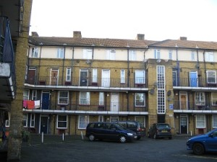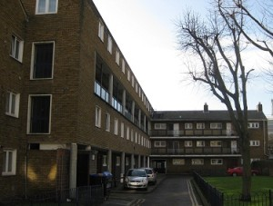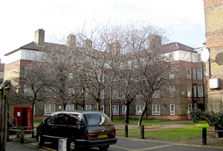

5. JMB vision and values
The JMB’s articles of association states that the JMB exists for the benefit of its members (residents).
The JMB was set up twenty-two years ago because residents’ representatives wanted more control over day-to-day repairs and estate cleaning services.
The JMB is a resident-managed organisation. It wants to be better than and different from other social housing managers. It is based on the principle of members’ representatives and staff working together to meet residents’ needs and aspirations.
The relationship between the JMB and its members is very important. For the JMB to continue to prosper it needs its members to get involved and participate in JMB activities. It is also important that JMB members know the JMB is always there when they need help.
Members are able to engage in a constructive way and make the important decisions that affect their lives. Additionally, there is positive working relationship between residents’ representatives and staff, which results in the co-production of services. These are the reasons why the JMB is different and better that other social housing managers, and the JMB is totally committed to building upon these strengths.
Respect and trust between members, directors and staff are important values for the JMB. The JMB operates on a human scale; people can see the positive difference they make.

6. Key performance indicators

6.1. Top quartile performance
The JMB relies on a number of sector-standard key performance indicators, which cover standards for critical services and measure the activities that contribute to the financial health of the organisation, such as rent collection. The Housemark consultancy specifies the standard that top quartile organisations should aspire to. As shown below, the JMB is a top quartile performer for most activities. This data can be compared against Southwark Council’s performance, as the Council and the JMB share similar objectives and confront similar challenges. Moreover, the JMB’s primary role is to deliver high-quality services on behalf of the Council.
Whilst the JMB’s performance compares favourably with other organisations, it wants to continue to improve.

  - Key Performance Indicators (KPIs)
KPI | JMB | Southwark | Top quartile | Date
Complaints responded to within priority time (within 15 days) | 79% complaints,  96% of members enquiries | 63% | 96% or more within target date | JMB: 31.12.17  Southwark: top quartile 30.9.17
Avg. response time | 6.7 days complaints  3.5 days members enquiries | 17.3 days | 10 days or less | JMB: 31.12.17  Southwark: top quartile 30.9.17
Repairs satisfaction | JMB: 100%  Elkins: 100%  OCO: 95% | 87% |  | JMB: 30.9.17  Southwark: 2017/18
Repairs completed within priority time | 94% (exc. heating) | 86% (Inc. heating) |  | 2016/17
Repairs first time fix | JMB: 96%  Elkins: 94%  OCO: 71% | 86% | 93% or more | JMB: 31.12.17  Southwark: top quartile 30.9.17
Rent loss due to properties being empty | 0.26 | 2.8% | 0.53% or less | 30.9.17
Avg. time to re-let empty properties | 22.8 days | 108 days | 29 days or less | 30.9.17
Current arrears as % of annual rent roll | 3.3% | 6.5% | 3.35% or less | 30.9.17
% of annual rent collected (exc. void loss) | 99.4% | 99.1% | 100% or more | 30.9.17
Secure tenants’ gas safety check  within 12 months | 100% | 99.7% | 100% | 30.9.17

6.2. TMO & Southwark Council satisfaction levels
Southwark conducts formal STAR surveys to measure tenant satisfaction amongst both the tenants it directly manages and those for whom management is delegated to TMOs. The level of service provided by Southwark TMOs is highly appreciated by their residents. Southwark has fifteen TMOs, including the JMB; the JMB represents 35% of the tenant-managed properties in Southwark. The JMB is delighted that in 2017, 92% of TMO tenants said that they would recommend their housing manager to friends and family, which compares favourably with 85% for the rest of Southwark. Furthermore, TMO tenants reported a 74% level of general satisfaction compared with 66% for tenants directly managed by Southwark. However, the fact that 26% did not express satisfaction with TMO services shows that there is still work to be done.

2016/17 - How satisfied are you with…
2016/17 - How satisfied are you with… | LBS | TMO | Overall
The services provided by us? | 65% | 74% | 66%
The overall quality of your home? | 56% | 61% | 56%
Your neighbourhood as a place to live? | 75% | 82% | 76%
The value for money for your rent/service charge? | 70% | 66% | 70%
How we deal with repairs and maintenance? | 48% | 52% | 48%
The Council listening to your views and acting upon them? | 44% | 47% | 44%
Would you recommend the Council/TMO as a landlord to your family and friends? | 85% | 92% | 86%

6.3. Deprivation information
Until the 1980s this area was characterised by working-class people doing working-class occupations, working the docks and in associated food factories, and having a council tenancy.
Since then there has been radical change. Industrial decline has coincided with the area becoming a much more popular place to live. As an LSE study has identified, gentrification has taken place around council estates, rather than as a consequence of the displacement of existing areas. As noted later in the Business Plan, however, this has meant that the sons and daughters of council tenants can no longer hope to move to private sector accommodation in the area. The gentrification effect has meant that buying an ex-council property has become an attractive option. As ex-Right-to-Buy (RTB) properties are sold, the social composition of JMB estates is changing substantially. As a counter-trend, access to council housing is increasingly determined by the intensity of need, as the housing crisis deepens.
As evidenced by the government proposal to sell off high-value empty properties, the role that council housing plays in maintaining social diversity in central London is under pressure.
The diversity of income and life experiences of people living in the area makes it very difficult to identify the level of social deprivation and other challenges faced by the JMB’s secure tenants.
Data has been analysed at Lower Super Output Area (LSOA) area level, with LSOAs having a median population of 1500. The Leathermarket JMB estates are located across eight LSOAs in Southwark. Five out of eight of these LSOAs rank amongst the 30% most deprived neighbourhoods in the country, with one area ranking amongst the 20% most deprived neighbourhoods in England according to the Index of Multiple Deprivation (IMD). Only one of these eight areas is ranked amongst the 50% least deprived neighbourhoods in the country.
Residents in these areas also experience significant barriers to housing and services compared to the national average. One LSOA is ranked amongst the 10% most deprived neighbourhoods in England in terms of Barriers to Housing and Services, and four of the other LSOAs listed rank amongst the 20% most deprived neighbourhoods in this domain.
Moreover, all eight of these LSOAs are ranked amongst the 20% most deprived neighbourhoods in the country in terms of Living Environment Deprivation, and three of areas are ranked amongst England’s 10% most deprived neighbourhoods in terms of Living Environment Deprivation.
The JMB estates are all located within the Chaucer and Grange wards, which have unemployment rates of 8.7% and 8.6%, respectively (higher than the mean unemployment rate of 7.6% across England and Wales). 3% of Chaucer residents and 3.2% of Grange residents claim out-of-work benefits (compared to 1.9% across England and Wales).
At least 43% of Leathermarket JMB’s tenants receive some benefits, with 36.9% receiving full or partial Housing Benefit and at least 5.9% confirmed as recipients of Universal Credit (UC). The actual proportion of tenants receiving benefits is likely to be much higher than 43%, but the structure of Universal Credit makes it difficult for Leathermarket JMB to collect comprehensive data on its UC recipients.
Additional information is provided in the HACT Community insight profile for the ‘Broader Leathermarket’ area:
- 54% of people aged 16-74 are in full-time employment, compared with 39% across England
- 32% of children are living in poverty, compared with 20% across England
- The overall crime rate is higher than the average across England, with a monthly crime rate around 35 per 1,000 population (compared to 10 per 1,000 population across England)
- 39.6% are in overcrowded housing, compared to 8.7% across England
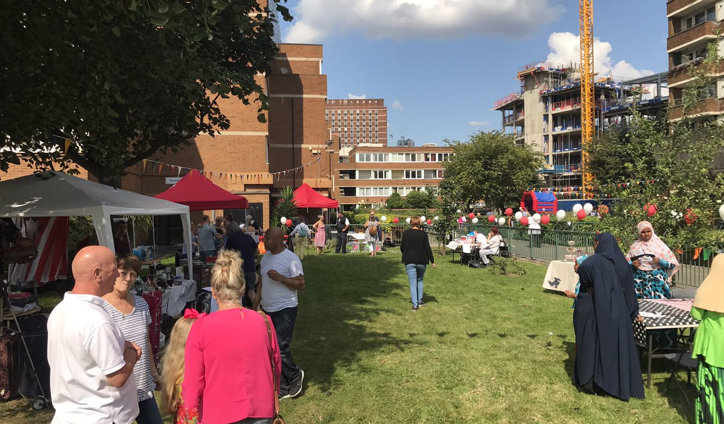

7. Objectives
The main objectives of the JMB are:

7.1. Top quality services

A. Introduction
Members pay their rent and service charges for top quality services and, to a large extent, judge the JMB by whether they are provided. This means we need to:
- Provide a reliable repair service
- Maintain clean estates.
- Provide attractive green spaces.
- Effectively tackle anti-social behaviour.
The JMB’s Performance sub-group has developed a very comprehensive performance-reporting regime, which measures issues of particular importance to residents. This information is evaluated on a quarterly basis. This information is also critical to operational managers, helping them to make decisions about how to best organise their services.

B. Challenges
The JMB faces similar challenges to other social housing organisations, such as providing a reliable repairs service and responding effectively if the JMB does not get things right the first time. Resident representatives and staff have worked to co-design solutions to these challenges.

C. Providing a reliable responsive repair service
Providing a reliable responsive repair service is one of the greatest challenges faced by social housing managers. The JMB also employs its own repair team. The way it evaluates the cost-effectiveness of its in-house team is based on the aggregate value of the repairs they have completed. The JMB evaluates what an external contractor would charge for this work, then compares this amount to the cost of employing and equipping the team.
As described later in this Business Plan, the JMB undertook a LEAN process review with the objective of increasing the productivity of the in-house team and reinforcing the reliability of the JMB’s repair service. The principles of the JMB’s repair service are:
- Local knowledge and continuity of staff, which makes diagnosing repairs more accurate
- Extensive checks on the quality of repairs
- Robust processes to minimise the chance of repairs being ‘lost’ within the systems. The JMB now issues repair receipt confirmations, if the repair is not being completed straight away
- Intensive management of difficult repairs
- An effective approach to resolving leaks from one property to another
- Post-repair inspections and tight financial control
- Employ a handyperson to allow the skilled tradesmen employed by the JMB to concentrate on more complex work.
Action: Implement LEAN review process recommendations.

Anti-social behaviour (ASB)
It is critical to reassure residents suffering the consequences of anti-social behaviour that the JMB is acting effectively on their behalf. This is a particular challenge when long-term intervention by an external agency is needed or when the JMB is waiting for a court date, which may take several months. For these serious long-term cases, the JMB issues an action plan, confirming the actions that are being taken, and stays in regular contact with the person suffering the consequences. It also follows a formal close-down procedure, which means that when the housing officers believes that the problem has been solved the JMB cross-checks this conclusion with the individuals who were experiencing the consequences of the ASB.
Action: Evaluate resident satisfaction with ASB management by April 2019.

Resolving problems
As a local community-led organisation, the JMB tries to resolve problems quickly and avoid the bureaucratic complaints policies employed by some larger organisations. Also, the JMB wants to retain a focus on the concerns of the majority of its residents and to provide extra support to its vulnerable residents, and not have its service delivery priorities distorted by persistent complainers.
Action: Write new complaints policy by April 2019.

Maintaining a pleasant environment
Evaluating the condition of a housing block over time requires multiple criteria, as a number of factors have an impact, including cleaning, gardening, major repairs, responsive repairs and anti-social behaviour. The JMB has implemented a joint - resident and staff - block inspection regime, named Housing Management Standards, which tracks the effects of all of the factors listed above.
The JMB has benefitted from the long-term commitment of its gardeners who, over a period of years, have made a noticeable difference to JMB estates.
The JMB is grateful for the support received through the Council’s Cleaner, Greener & Safer programme in providing funding for gardening and lighting improvements.
Action: Poor ground conditions has meant that the condition of green areas on the Elim and Meakin estates does not match the rest of the JMB area. This will be addressed over the next two years.

Leaseholders
Across London, leaseholders report substantially lower levels of satisfaction than secure tenants. Whilst secure tenants contribute to a pooled Housing Revenue Account a relatively consistent amount over a period of time, leaseholders pay the actual costs of running the block relatively soon after the costs are incurred. Major refurbishment can cost tens of thousands of pounds per flat, and the need to recover service charges means that the relationship between homeowner and landlord (or managing agent) can become fraught.
To try to change this relationship, the JMB intends to do things differently. The directors and senior managers devoted their planning day in January 2018 to discussing how the leasehold management service will be taken forward. Additionally, the JMB has established a Leaseholder Project Team to work through a series of issues and identify where leaseholders can have a direct influence on the services they receive.
Improving the quality of communication and explanations to leaseholders has emerged as a priority. The fact that the provision of the leasehold management service is currently split between the JMB and the Council has meant an inefficient and disjointed approach to the administration of service charges. The JMB will provide an integrated service. Moreover, since the JMB operates on a smaller scale than the Council, it can offer a more personalized service.
In preparation for taking over the full range of leaseholder services the JMB has undertaken an intensive training exercise with directors and staff.
The decision by the JMB to take on full responsibility for leasehold management is also financially driven. Post self-financing, the Council has charged for the leasehold administration work it undertakes, and this charge cannot be levied once the JMB takes on these functions. Similarly, the Council levies a 10% administration fee for administration work it undertakes in consulting, billing and collecting major works service charges. Absorbing leasehold management into the JMB’s existing management framework will be achieved within existing budgets, and by utilizing the existing staffing resource.
Action: The JMB will take on all but the most specialised aspects of leasehold management from April 2019.

7.2. JMB members

A. Participatory democracy
The principle of participatory democracy is very important to the JMB. For the JMB, this means that residents are genuinely in control. In 2013 the JMB invited specialist consultants PPCR to undertake a study on how the JMB could communicate and engage with its residents more effectively. This study resulted in a 2013 Resident Participation Strategy. Progress was reviewed at a directors’ and managers’ away day in 2017.
A key principle for the JMB is to give residents the opportunity to make the big decisions that affect their lives by participating in our democratic structure, either directly or through their representatives.
The JMB believes in resident activists and staff working together to co-design the way that services are organised and to monitor delivery, as the best way to provide excellent services.
The JMB is only as strong as the level of resident participation that it can generate. The JMB aims to give residents different options for participation, depending on their interests and the time they have available. The JMB values volunteers’ time, knowing that for people to donate time they must feel that they have been listened to and that their contribution has made a difference. Getting involved in JMB activities should be personally rewarding and fun.
Meetings provide a vital forum where issues are debated and people are potentially influenced by hearing others’ points of view; thus, meetings remain an important part of the decision-making process. However, the JMB realises that some residents cannot get to meetings and supplements this approach by providing information and the chance to comment via electronic platforms. The JMB regularly updates the rolling news on its website, and sends out frequent Facebook and Twitter updates.
The challenge for the JMB is how to ascertain and effectively deal with the concerns of its most vulnerable and excluded residents. The JMB has a structured programme of keeping in regular contact with vulnerable residents. The housing team try to make contact with every tenant at least once every three years. The JMB also has a continuation ballot every five years, at which point its volunteers and staff make a concerted effort to speak to every resident and hear their opinion.
Tenants and Residents Associations (TRAs) are an important part of our democratic structure. Each of our five TRAs elects two directors annually at a public meeting. These elected directors play a key role in promoting two-way communication between the board and the TRAs.

JMB Board

CBS Board

Bermondsey Street

-
2 directors

Kipling

-
2 directors

4 co-opted directors

Directors elected by members

Decima Street

-
2 directors

Lawson

-
2 directors

Crosby, Lockyer & Hamilton
-
2 directors
1 nominee
Sustaining a successful TRA is difficult for volunteers, so the JMB is committed to providing as much support as it can.
On the JMB Board, the elected TRA directors are supported by four co-opted directors, who bring knowledge of their specialist areas to board discussions.
The JMB board delegates detailed scrutiny of different areas of its activity and defined decision-making responsibility to five sub-committees, as shown in the chart below. The remit of these sub-groups is set out in the JMB’s Code of Governance. The board also sets up project teams from time to time to help plan strategic tasks. At present, one project team exists to oversee the implementation of our changes to the delivery of services to leaseholders, as described above.
The sub-committees and project teams are made up of both JMB directors and other interested residents. Participation in sub-groups and tenants’ associations provides interested residents with a pathway to become full directors. This sub-group structure also allows the JMB to benefit from the knowledge and interest that a resident may have in a particular area.

Leathermarket JMB Board

Leathermarket CBS

LEASEHOLD PROJECT TEAM

COMMUNICATION AND
PARTICIPATION

PERFORMANCE

STAFFING

FINANCE

MAJOR
WORKS

Action: A training needs analysis for directors is being conducted, which will be used to inform a directors’ training programme by April 2019.
TRAs - like all groups run exclusively by volunteers - have both high and low points, and the JMB provides support to TRAs when they need it.

B. Community cohesion
The JMB is delighted that people from diverse backgrounds, with a variety of life experiences and incomes, live in its blocks and cooperate to support the JMB and other community initiatives. For the JMB to continue to thrive, there needs to be strong community cohesion. In conjunction with other active TMOs, the JMB organises community events such as trips to the seaside and an annual Fun Day. The JMB works hard to ensure that the most disadvantaged residents get the chance to participate in its activities.
The JMB has worked in collaboration with other agencies on numerous occasions. Partners at the time of writing are:
- The Voices Project, which aims to give young people a voice through music, theatre and film. The JMB is working together with the London College of Communication and Awkward City Theatre Company, with Arts Council funding.
- A water conservation project conducted in collaboration with University College London (UCL), Imperial College and Oxford University. This is a research project with the aim of raising awareness and involving residents of council estates interested in water conservation projects.
Action: The Communication and Participation sub-group is evaluating which social activities are most inclusive and appreciated by residents. The JMB wants to prioritise social activities for those who would be least likely to take part in them, due to low income, poor health, or isolation.

C. Organised compassion
As the route into council housing becomes increasingly based on an assessment of needs, it must be recognised that many of those seeking access to council housing have led difficult and insecure lives. Therefore, security of tenure, a reasonable rent, and a safe place to live are of great importance to those who become JMB tenants.
In this time of public sector austerity, the JMB is very concerned about the level of support received by its most vulnerable residents, especially where mental health is an issue. In our equalities survey, 22% of tenants either described themselves as vulnerable or staff members have had a reason to apply this classification. The JMB has thirty-one tenants who find independent living very difficult and who require a high level of support. Of these, there are nine who can be classified as extreme hoarders. A consequence of hoarding, which is correlated with acute mental health problems, is that there is an increased fire risk. In some cases, these homes are not hygienic.
The JMB seeks to adopt an organised, compassionate approach, by which it means that it provides effective support to vulnerable residents based on their specific needs. This includes helping vulnerable residents get the external support they need.
The JMB is aware that the most vulnerable residents may have lower expectations and knowledge about the services that they should be receiving, and are less willing and/or able to complain if they feel let down.
As described in the finance section, being part of the pilot area for the roll out of Universal Credit has also been very difficult for tenants who have been affected. The JMB has worked hard to support these people and has well established links with external agencies such as mental health services, Rightfully Yours, who provide benefit advice and the St. Olaves charity, who provide respite holidays and financial assistance.

7.3. Maintain and upgrade residents’ homes and environment

A. Introduction
When the JMB became self-financing it stated that its priority would be to tackle the backlog in maintenance and refurbishment work (major works) on its estates. The background context for this pledge is that none of the JMB estates have benefited from systematic improvement works since the late 1970s and early 1980s. In Southwark there has not been a stock transfer or ALMO, and consequently, the area has not seen the higher levels of expenditure on major works and refurbishment works seen in other boroughs.
The JMB has started to make inroads into its major works backlog, by significantly accelerating its delivery of major works. In the last financial year, 2016/17, 46% of the money paid by JMB residents in rent and service charges and not paid over to Southwark Council was reinvested in major works on the JMB estates. The remaining 54% has been spent on our other services, such as responsive repairs, estate cleaning, and tenancy and leasehold services.
The pledge that the JMB gives to its residents is:
“Our first priority is to make sure that you, your homes, and your estate are safe, and that basic services work.
Secondly, we need to make sure your homes last as long as they can. Thirdly, we want our estates to be places that you and your neighbours can be proud of.”
The JMB has undertaken a detailed stock condition survey and developed a detailed 13-year plan. As noted earlier, thirteen years is the time calculated from its current starting point to tackle the issues below, at a total cost of around £27m:
- Tackle all known major disrepair problems.
- Undertake safety works.
- Catch up on the current backlog of concrete repairs and external decorations.
- Ensure that tenanted properties remain Decent Homes compliant.
- Start to address the issues raised by residents in its 2017/18 Estates Improvement Plan consultations.

B. Fire Safety
In the aftermath of the Grenfell Tower tragedy, fire safety has become an issue of even greater importance. Southwark Council has significantly stepped up its inspection regime, and this has generated a dramatic increase in both physical works and housing management tasks. The JMB has a managed approach to fire safety, which means making sure that fire exits are unobstructed and that combustible items are not left in public areas. The JMB is also ensuring that all metal grills are removed from front doors.
Fortunately, the JMB does not have any blocks with flammable cladding or have load-bearing panels (many of these types of system-built blocks have safety and compartmentalisation issues). When a property becomes vacant in a block over 30 meters in height, the JMB is working in conjunction with Southwark Council to conduct an invasive test to check the compartmentalisation.
The JMB is providing all residents with a fire-safe, high-security front door, and all residents who live in blocks of flats with an integrated electrical fire and smoke alarm system. The JMB will also be fitting a fire and smoke shut-off arrangement to the mechanical ventilation system in Symington House. Within its 13-year plan, the JMB has made financial provisions to fit sprinklers into all of its high-rise blocks, if the Grenfell Tower Inquiry recommends this.

C. Estate Improvement Plan
The JMB benefited from government funding to undertake a major consultation with its residents. The objective was to identify further new build sites and to discern residents’ priorities for the upkeep and improvements of their homes, blocks, and estates over the next 20 years.
The consultation was comprised of almost 500 completed surveys, 8 consultation meetings, 3 follow-up conversations, and 2 drop-in events at the JMB offices that focused on estate-wide consultation. Consultation boards were also available in the JMB office for over a month. It is estimated that at least 600 people participated.
Amongst the survey respondents, 373 identified themselves as council tenants and 45 identified themselves as leaseholders, although many people skipped this question.

D. Survey Results
The following major concerns were raised through responses to various questions across the Estate Improvement Plan survey:
- Security; 50% want to see security improvements (ex. entry phone), and 29% mentioned anti-social behaviour or issues with neighbours as the thing they dislike most about their estate
- Parking; 31% want to see parking areas re-planned
- Refuse/Bins; 31% want to see refuse areas re-planned, and 11% said that rubbish issues are the thing that they dislike most about their estate
- Bathrooms; 30% said that bathroom works should be among the JMB’s top three Major Works priorities
- Lighting; 24% want to see lighting improvements
- Green areas; 23% want to see continued improvements to the green areas, and 25% identified landscaping as a low cost idea that could make a big difference to their estate
- General appearance; 16% mentioned the appearance of the estate/buildings when asked what the JMB’s top three Major Works priorities should be (external painting, deep-cleaning), and 7% mentioned aesthetics as the thing that they dislike most about their estate
- General repairs and maintenance; 12% mentioned general repairs and maintenance when asked what the JMB’s top three Major Works priorities should be, and 10% mentioned maintenance concerns as the thing they dislike most about their estate

E. 13- Year plan
The JMB has a 13-year plan which will allow it to achieve the objectives set out in the introduction above. This plan is based on a cautious estimate of how much it will be able to spend - about £1.6m per year, at 2018 prices. The JMB has also given a commitment to its residents to set out its medium-term plans, so that tenants and leaseholders can plan their own internal improvement works, and leaseholders know what works they need to make provisions for.
In the JMB’s experience, work that it was planning to do in a number of years’ time can suddenly become more urgent. Recent examples include failing communal heating systems on Meakin and Kipling estates and corroding mains water pipes in two tower blocks, Simla House and Burwash House. The way that the JMB has dealt with this to date is by changing its programming, i.e. bringing this work forward while delaying other work. This is why, in all of its consultation with residents, the JMB has been very clear that its plan could change in the event of a major service failure.
Over the past five years, the JMB board has invested a proportion of its members’ fund (surplus) into major and planned works. In its 2017/18 audited accounts the JMB reported that it held emergency reserves of £598,000, which could be used if an emergency repair situation arises.
The 13-year plan that the JMB is consulting upon in March 2018 is set out below:
  - 2018/19
- Symington House security works
- Continuation of security doors: Dunsterville Way, Mulvaney Way, Heldar Court, Guy Street
- Lawson Estate external works phase two: Nashe House, Munday House, Greene House, Lyly House, Jonson House and council owned cottages on Burbage & Chettle Closes, including roofing works, decorations, concrete repair, lighting & refuse arrangements
- Continuation of fire alarm works
- Whites Grounds Estate party wall renewal (when a party-wall dispute is resolved)
  - 2019/20
- Continuation of Lawson Estate phase 2 works
- Crosby Row block external works, concrete repairs, decoration and lighting
  - 2020/21
- Hamilton Square external redecoration, concrete repairs, decoration, and lighting & refuse arrangements
- Replacement of communal heating for low-rise Kipling Estate residents: Dunsterville Way, Heldar Court, Mulvaney Way, Guy Street
  - 2021/22
- Cardinal Bourne House complex communal boilers replacement
- High-rise sprinkler systems: Nashe House, Peveril House, Symington House, Simla House & Burwash House (this work will only be undertaken if recommended by the Grenfell Tower Inquiry)
- Symington House mechanical ventilation system
- Communal water tank renewal: Symington House, Tanner House, Rephidim, Meakin Estate, Beeston House, 1-21 Whites Grounds Estate and Snowsfields
  - 2022/23
- Decent Homes bathroom replacement for tenants only
- Lift renewal: Munday House and Beeston House
- Tyers Estate, Whites Grounds Estate and Tanner House external works, concrete repairs, decoration and lighting
- Continuation of sprinkler work for tower blocks
  - 2023/24
- Cardinal Bourne House complex and Bartholomew Street town houses externals
- Individual central heating up-grade – tenants only
- Lockyer Estate and Archdale House lateral mains renewal
- Continuation of lift renewal for Munday House and Beeston House
  - 2024/25
- Simla House and Burwash House externals, concrete repairs, decoration and lighting
- Trinity Street (25, 31) hallways & externals, and Brockham Street houses (owned by the council) external works
  - 2025/26
- Low-rise Kipling Estate externals, including concrete repairs, decoration and lighting
- Lockyer Estate externals, including drainage, concrete repairs, decoration, refuse and lighting
  - 2026/27
- Tyers Estate underground mains & internal soil stacks
- Reconfiguration of Hamilton Square basement flats to make lighter and larger
  - 2027/28
- Symington House externals, concrete repairs, external decoration and lighting
- Falmouth Road externals, roof renewal, external decoration and lighting
- Peveril House, Falmouth Road & Cardinal Bourne House complex kitchen renewal

  - 2028/29
- Peveril House and Rephidim Street externals, concrete repairs, decoration & lighting; Peveril House internal soil stacks and refuse arrangements
- Archdale House and Mendham House externals, including concrete repairs and decoration
- Nashe House lift upgrade
  - 2029/30
- Drainage works across the JMB, as required
- Symington House, Lyly House, Greene House and Jonson House lift upgrades
  - 2030/31
- Street properties, Crosby Row, Weston Street & Long Lane houses externals
- TRA hall upgrades
- Courtyard upgrades
- Villiers Court & Marklake Court externals
- Garage repairs
- Flat re-configuration for a handful of very small flats in 1930s blocks
  - What happens beyond April 2031?
The JMB also plans over a 30-year period. It has a comprehensive stock condition survey, from which it is possible to calculate future replacement needs for building components, such as the roof and windows, based on building industry standards. The JMB is currently consulting (March 2018), and will be using this information, residents’ comments, and a formal response from the Council as the (property owners) to update its plan.
Action: Deliver major works programme.
As part of its financial planning, the JMB needs to calculate the level of debt it can sustain and, if appropriate, seek access to the Council borrowing headroom as a means of accelerating its major works programme.

F. Minor estate works
The JMB is aware that it can make a difference to residents with relatively small amounts of money, by undertaking works such as clearing roof gutters, tidying up loose high-level wiring, and planning more parking spaces. For the past two years the JMB has had a minor estate improvement programme, whereby, in consultation with residents, we identified low costs works that will have a big impact, such as roof guttering and creating more parking spaces.

G. Healthy homes – condensation
Making sure that homes are healthy for people to live in was a fundamental principle that drove the expansion of council housing from its inception. The JMB has a number of 1930s single brick blocks and a block with concrete infill panels, where there is a higher chance of condensation occurring. The JMB is working towards a systematic approach to tackling condensation. The four strands of this approach are:
- An allocated budget (2017) to pay for an anti-condensation works
- Mapping condensation problems by property, to identify the most vulnerable blocks
- Working in partnership with the residents to tackle condensation. On each visit The JMB issues a condensation pro-forma, which confirms the action required by both the JMB and resident
- The JMB is working in collaboration with UCL on a research project, which will lead to a better understanding of why condensation occurs and the most cost-effective remedies

I. Major works quality
A significant challenge during the last 5 years has been to accelerate the delivery of major works, whilst ensuring that high quality work is delivered. The JMB board has undertaken two comprehensive reviews and set out its objectives and solutions:
  - Produce a high quality specification of works
- Commence a technical consultant re-procurement exercise
- Publicise the proposed specification of works before writing the contract, so that interested residents can comment
- Offer more in-house challenges to the specification prepared by the Technical Consultant
- Ensure that the technical consultant produces a bespoke specification for each block, rather than a pattern and repeat specification
  - Ensure that high quality major works are delivered:
- Set out quality expectations to potential contractors before they are invited to submit a tender return
- Introduce a price and quality criteria for contractor selection
- Devise key performance indicators to evaluate the quality provided by contractors
- Introduce a default procedure
- Explicitly specify a high quality builders’ clean
- Undertake a formal evaluation at Major Works-sub, at the end of each substantial project
  - Quicker resolution of problems whilst the contract is underway
- Publicize the role of the JMB’s Major Works Manager and Resident Liaison Officer in resolving residents’ complaints
- Provide residents with an overview of how JMB works are organized, and the service standards they should expect
- Seek to settle the draft final account within three months of practical completion and serve default notices if contractors seeks to delay rectifying faults that become apparent, after the contractor has left site until the end of the defect liability period
- Conduct mid-contract satisfaction surveys and ensure effective follow-up.
  - More cost certainty for the JMB and leaseholders
- Competitively tendering work, rather than entering into a partnering arrangements, to ensure price competitiveness
- Include in brief for the Technical Consultant a requirement to map services e.g. electricity and water, within blocks and estates and to check for fire safety compartmentalisation issues
- Require the Technical Consultant to minimise the use of provisional sums and ensure that appropriate pre-works investigations are carried out
- Ensure that the Technical Consultant is explicit about the project risks and where those risks lie; Replace a generalised contingency sum with a quantified risk pot
Action: Implement quality major works plan.

7.4. Meet housing need

A. Analysis of housing need
Southwark Council, rather than the JMB, controls allocations. However, the JMB still wants to do what it can to help people in housing need. For those canvasing for the JMB’s continuation ballot in 2011, housing need was a major issue on the doorstep.
A high number of JMB tenants live in unsuitable properties, either because they are overcrowded, under-occupying, or the property is unsuitable for the medical conditions of a household member. A particular issue for the JMB is the number of long-standing residents living in 1930s walk-up blocks who are finding it increasingly difficult to manage the stairs.
The JMB has undertaken three studies of housing need, a postal and website survey in 2012, interviews conducted with 513 tenants in 2014, and interviews conducted with 373 secure tenants in 2017. The three surveys, taken together, offer an informative analysis of housing need.
In the 2012 survey, 10% told us that they had a reason to be re-housed but were not registered on the housing list.
In the 2014 survey, 36% of tenants said that they had a qualifying reason to move. Within this group, the reasons for wanting to move were:
- Overcrowding: 42%
- Health/mobility problems: 21%
- One or more adult household members who want to live independently: 15%
- Move out of the area: 7%
- Other reason: 10%
In the 2017 survey, 30% said that they had a qualifying need to move. Within this 30% the reasons to move are:
- Overcrowding: 70%
- Health/mobility problems: 23%
- One or more adult household members who want to live independently: 6%
There are two interesting observations here. Firstly, no one who was under-occupying saw this as a reason to move, unless they were affected by the bedroom tax. In 2013, the Southwark Independent Housing Commission found that 30% of tenants across the borough are overcrowded, whilst 15% are under-occupying. The Commission proposed that more be done to address this imbalance.
As of March 2018, the JMB is aware of 101 overcrowded households and 55 under-occupying tenants in its properties. As a local community-based organisation, the JMB knows which tenants might downsize if the right accommodation is offered. In the case of some tenants, ‘hand-holding’ support is also offered to make the prospect of moving less intimidating. Unfortunately, the closing of the Better Fit scheme severely limits the JMB’s ability to address this problem.
Secondly, in 2017 38% of those who thought they had a qualifying reason to move said that they were not registered or did not know if they were registered for rehousing with the Council. Southwark has introduced an annual re-application process and bidding criteria that has left many people confused, especially the most vulnerable. Vulnerable tenants are less likely to be able to navigate their way through the Council’s registration process and, even when registered, are more likely to drop off the Council’s housing list.
Another trend is that the people who are overcrowded are more likely to be living in smaller 1930s properties, whilst those under-occupying are more likely to be living in larger 1950s/ 1960s properties. For the reasons set out in the equalities section, black people are more likely to be overcrowded and living in small properties. Within the 101 over-crowded properties that the JMB manages, 61% of households describe themselves as black and 23% as white. The ethnicity of 16% is unknown.
Whilst white people are more likely to be living in larger properties and under-occupying, this trend is less pronounced; 53% of under-occupying households describe themselves as white and 42% as black.
  - Private ownership or renting
The JMB is located within an area of very high property prices. The 2012 survey confirmed that private ownership or renting in the area is only an option for a very small proportion of JMB residents. This is a critical issue for adult sons and daughters who continue living with their parents. Survey respondents reported that:
- 99% of households have a household income of less than £30,000;
- 56% do not have any money for a deposit if they wish to buy a property;
- 85% would not have the money for a deposit if they wished to rent privately;
- 93% cannot afford a rent above £200 per week, or the maximum amount that housing benefit will pay.
  - Remaining within the JMB area
The 2012 survey also confirmed anecdotal evidence that most JMB residents had a compelling reason to stay in the area. 77% said that staying in the JMB area was important to them. As well as family and friends in the area, residents value the personal support that they get from JMB staff. For another 38% of residents, participation in local community groups is a reason to remain in the local area.

B. Community Benefit Society (CBS)
The JMB believes that it is important that new homes, to be let at Southwark Council rents, are built in the SE1 area. These homes should be affordable for JMB residents and not pass into private ownership (and especially into the buy to let market) through the right to buy. The JMB has set up a separate mutual community organisation, named Leathermarket Community Benefit Society (CBS), to take forward its new build aspirations.
The JMB established Leathermarket CBS in 2013, with the objective of building new council-rent homes for JMB residents. The CBS has a separate legal identity and there is a separation of financial and governance responsibility.
The first 27 CBS homes, at Marklake Court, are being built on an old garage site on the Kipling Estate and will be finished in the summer of 2018. Another 40 homes will be built on an old nursery site on the Lawson Estate, with work anticipated to start in early 2019.
The CBS has also been successful in attracting £827,335 of external funding to help tackle the housing crisis in the borough. The sources include the Government’s Estates Regeneration and Community Housing funds and the GLA’s Community Right to Build Fund.
As the CBS may at times need to continue without funding, or funding may be in arrears, the JMB’s members have agreed to a £200,000 cash flow loan.
The CBS has also led on the Estate Improvement Plan consultations. As part of the consultations, residents were asked about further estate infill sites for new homes.
The building of new homes would have been a significant departure for the JMB from its core activities. The JMB did not want this major undertaking to be distraction or create a financial risk. This is why the JMB created a separate organisation, which has directly employed an experienced project director and two community liaison officers.
Action: In the spring of 2018, CBS directors will review the outcome of the Estates Improvement Plan consultations and identify the next phase of CBS new builds.

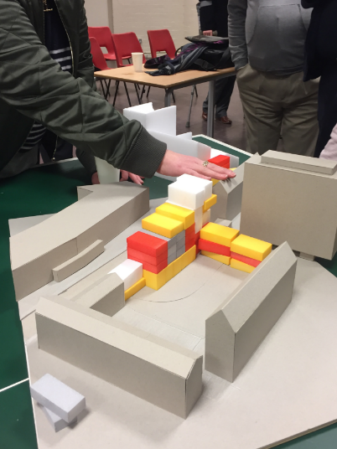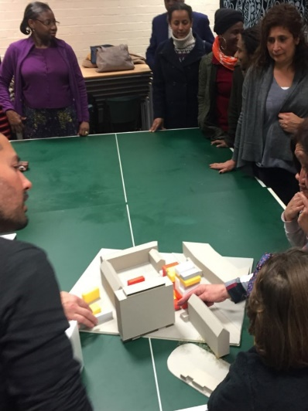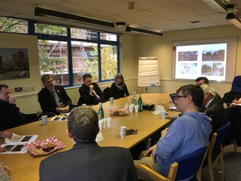

C. Better fit
Between April 2013 and September 2015 the JMB helped sixteen tenants to ‘right-size’ and stay within the JMB area. This also meant that the JMB was starting to address the historic racial disadvantage previously described. This ‘right-sizing’ represented around 14% of the total allocations during this period, and the Better Fit allocation resulted in an empty flat being offered to the Council for allocation. Unfortunately, the Council has stopped this scheme. To compound the problem, the Council has withdrawn access for JMB staff to check tenants’ re-housing applications.
The JMB remains convinced that, subject to appropriate equalities checks, a locally-based organisation has a significant opportunity to achieve the Council’s aim of reducing over-crowding and under-occupation within its housing stock. To do so, however, the JMB needs to have the flexibility to let 15% of its annual void turn-over on a Better Fit criteria.
Action: Work collaboratively with Southwark Council to address the housing needs of existing tenants and, in particular, to address the mismatch between over-crowded and under-occupying tenants.

D. Void turnaround times
The intensifying housing crisis makes letting empty properties quickly even more important. Between April and October 2017 the JMB’s average turn-around time was 22 days, compared to Southwark Council’s 108 days.

E. Unlawful occupants
As a resident-run organisation, the JMB takes tenancy fraud very seriously. As a local organisation, the JMB taps into the information networks of both its residents and staff. Between April 2016 and October 2017 the JMB has either evicted or persuaded to hand back the keys five tenants who were unlawfully sub-letting.

8. Building blocks
There are four essential building blocks for achieving the objectives and meeting the challenges set out above. These building blocks are:

8.1. Governance
The effective oversight of JMB activities requires continuity of knowledgeable and committed directors, complemented by other members who come along and have their say.
The experience of many working people is that more privileged people make the decisions that affect their lives. Resident management is unusual in that it gives working people the opportunity to make these big decisions. JMB resident directors have joint control over a £7m budget, set the agenda for the organisation, and negotiate with government ministers and local authority leaders.
The JMB supports residents to feel confident about coming forward to be directors, by making sure that they are provided with information and support to effectively represent the views of residents. This means supporting incoming directors to develop the values, knowledge, and skills needed to help realise residents’ aspirations. The JMB is also fortunate to have attracted high-calibre external co-opted directors to support its work.
Key documents include the JMB’s Code of Governance, directors’ contracts and directors’ job descriptions. Each incoming director has an induction session conducted by the chair and manager. The JMB also holds an annual away day to review strategic priorities and benefits from the annual weekend of intensive workshops offered by the NFTMO.

8.2. Excellent employer of excellent staff

A. Overview
The objectives set out in this Business Plan require excellent staff to deliver them and continuity of knowledgeable and committed staff, especially in senior positions. The JMB has benefitted from continuity of senior staff, but this does mean that the JMB needs to turn its attention to succession planning.
The JMB places a high emphasis on performance management and taking a structured approach to training. The JMB sets an organisational work plan, based on Business Plan objectives, which then provides the basis for individual work plans.
The JMB’s Staffing Group agrees an annual Training Plan, which sets out strategic, operational and professional development training needs.
The JMB is a dynamic organisation, expanding its area of operation to take on a wider range of leasehold services and providing support to smaller TMOs. This means that the JMB can offer job enrichment opportunities, which is important given that the JMB is a small organisation with a low staff turnover.
Action: The JMB is formally reviewing the distribution of duties within the existing staff team.

B. Lean
The JMB undertook a LEAN process review during 2017, with the aim of identifying where changing processes could increase staff productivity, reduce costs, and increase the reliability of service delivery. The approach taken by the JMB was to employ an external facilitator to work with the staff delivering the service, to review processes, and quantify the outcomes.
The motivation for the review was to improve services without increasing costs, as well as to free up staff time to take on leasehold responsibilities. Subsequently, fire safety work has led to a significant increase in workload, with no increase in income, which would have allowed the JMB to increase its staffing levels.
The main outcomes of the LEAN review are:
- Changed working practices, such as work scheduling and more single-person working, will increase the productivity of the in-house repair team.
- Tighter process will increase repair reliability and reduce the amount of disturbance handling undertaken by repair managers and administrators.
- The JMB’s early arrear process should be more computer driven, allowing rent officers to focus on more complex cases and to take on leasehold service charge collection.
- The process for issuing estate parking permits should be less time intensive for residents and staff.
Action: Implement 2017 LEAN review recommendations.

C. General Data Protection Regulations (GDPR) & electronic document management
The implementation of the General Data Protection Regulations, from May 2018, will necessitate significant changes in work practices. These new regulations have also prompted the JMB to move to implementing electronic document management. The JMB recognises that there are significant workload implications for office-based staff. The challenge for the JMB will be to maintain its existing level of service, whilst ensuring that it is compliant with the new regulations and implementing electronic document management.
Action: Ensure that the JMB is GDPR compliant.

D. Information technology
The JMB’s development over the next 5 years is dependent on a number of IT initiatives:
- Leasehold service charge administration
- Electronic data management
- Repairs work scheduling for in-house team & repair reliability
- Early rent arrears work
- Automating rent accounts
- Web-based parking permit application process
- Website development
The JMB does not have an IT specialist, which has slowed down progress to date. To remove this impasse an IT Project Manager will be recruited on a 12-month contract. One of the roles of the incoming Project Manager will be to support the development of knowledgeable staff (super-users) in each section, so that the JMB becomes more self-sustaining.
Action: Recruit an IT specialist by June 2018 and develop staff super-users.

8.3. Financial management

A. Introduction
Effective control and direction of its finances is of critical importance to the JMB. Detailed scrutiny of spend against budget is exercised by the finance sub-group. In the years following self-finance, very favourable reports have been received from the JMB’s external auditor about financial management.

B. Self-financing
The JMB needs both sound financial management and to take advantage of the opportunities presented by self-financing, to maximise the benefit to residents and to catch up and deliver a sustainable major works programme that matches the 30-year asset management requirements. In the first five years of self-financing, unexpected Government-imposed rent cuts and welfare reform have proven to be significant challenges that had not been foreseen when the original self-financing plan was agreed. This is true for the JMB as well as for all other local authorities that have become self-financing.
In 2013, Southwark Council devolved responsibility for its slice of the Housing Revenue Account (HRA) to the JMB. The JMB manages approximately 3% of the borough’s housing stock. Though self-financing, the JMB retains a commensurate amount of income based on the rent of JMB tenants and the service charges for JMB homeowners. In return, the JMB is paying off a proportionate amount of the debt of all Southwark properties, paying a fair share of attributable LBS core costs, and buying retained services from Southwark Council.
The current exceptions to the self-financing principle are:
- The JMB did not receive a proportion of the HRA reserves when it became self-financing
- The JMB does not benefit from commercial income, which is approximately 5% of the total income of the HRA
- The JMB did not benefit from extra Government funding for decent homes work
- The JMB has not been offered access to the Council’s borrowing headroom
After five years of running self-financing, it is appropriate to undertake a comprehensive review of the progress made against the original 30-year plan and to review the assumptions in light of the reality of the macro-economic environment and legislative changes. In parallel to this Business Plan, a comprehensive review is being undertaken to ensure the JMB continues to be able to balance the competing financial pressures of meeting its service delivery aspirations and fulfilling its asset management requirements. The financial management section of this business plan will be updated with the projections of future income and expenditure based on the most up-to-date figures once the 2018/19 budgets are agreed at Board in March 2018.

C. Income and expenditure
Directors’ strategic priority for the first five years of self-financing was to maximise the major works budget through constraining the operating budget and the release of reserves. This priority was agreed to address the historic backlog of works that built up prior to self-financing.
In the last year of allowances (2012/13) £1.44 million was spent on JMB major works by Southwark council in addition to the management and maintenance allowance. At the time the JMB was told to expect this sum to go down to £1.1 million from 2013/14.
The JMB has managed to increase spend to £2.95 million in 2016/17 by keeping firm control of operating costs, making operating surpluses and releasing reserves to major works. Overall the JMB spent £730,000 more on major works in the first 4 years of self-financing than the 30 year plan estimated.
  - Change in audited income & expenditure and major works spend
 | Allowances | Self-financing
 | 2012/13 | 2013/14 | 2014/15 | 2015/16 | 2016/17
Income | £2,419,005 | £6,855,042 | £7,019,427 | £7,744,551 | £7,177,611
Expenditure | £2,288,781 | £6,502,441 | £6,503,443 | £6,644,353 | £7,284,496
of which major works | N/a | £1,573,866 | £1,871,653 | £2,173,068 | £2,951,751
% income spent on major works | N/a | 23.0% | 26.7% | 28.1% | 41.1%
30 year self-financing plan anticipated budget MW |  | £1,645,761 | £1,821,044 | £2,046,483 | £2,326,553
LBS spend on major works | £1,440,834
Surplus / deficit after tax | £133,922 | £357,739 | £522,588 | £1,106,958 | -£103,455

Income is volatile due to the uneven receipt of major works contributions from homeowners, which was compounded in the first three years of self-financing by a delay in receiving this money from Southwark, resolved in 2015/16, explaining the surge in income that year. When the JMB takes control of leasehold administration this will not be an issue.

The pie chart below shows income in 2017/18. As can be seen, the JMB is predominately financed by rent paid by its secure tenants and service charges paid by its leaseholders.

The graph below shows how this money was spent in 2017/19. A priority is catching up on the major repair backlog. 39% of the JMB’s expenditure was on major works. This proportion increases to 46% if the debt repayment and service costs paid to Southwark are excluded.

D. Financial Planning
Looking forward to the next five years, income is currently being squeezed by a number of factors:
- 2018/19 is the third year of four in which government policy mandates that rents are reduced by 1% per annum. This reduction was against a projection of inflation plus 0.5% plus £2 per week that was modelled when self-financing was agreed. At the end of the four years of cuts the JMB was modelled to have a cumulative £1.7 million less rental income than originally predicted.
- The JMB is in a universal credit pilot area. The delay for residents in receiving their benefit and the difficulty some residents have in budgeting is affecting the cash flow for the JMB in collecting their rent.
- Forced sales is the biggest threat to the sustainability of the JMB as most, if not all, JMB properties are likely to be regarded as high value due to the location next to the City of London. This is currently a risk, with the legislation remaining on hold.
- A smaller risk is an increased uptake of right-to-buy from existing tenants. It was feared that the rate would go up significantly when discounts were increased. So far the reality has been more modest, however, with the discounted value of the properties beyond the reach of most JMB tenants
To mitigate the risks to the JMB’s income from these factors, the JMB is broadening the services it delivers. These services will also spread the fixed costs of the JMB over a wider base:
- Taking on homeownership services, initially with the calculation of variable service charges, then the billing and collections will retain more of the money paid by JMB homeowners.
- Managing more properties, with 21 properties in Villiers Court and 26 in Tanner House already taken on. Furthermore, Leathermarket JMB will take on the management of the 27 Marklake Court properties currently nearing completion on the Kipling Estate;
- Delivering services to other TMOs including a comprehensive management service for Falcon Point TMO and a service contract for Kennington Park.
Detailed financial projections for the full five years of the business plan, and outline projections for the remaining 25 years of the 30-year plan, will be undertaken in April 2018 once the 2018/19 budget is agreed, so as to track the impact of these risks and to inform mitigating strategies on the projected income and expenditure of the JMB.

E. JMB reserves policy
The JMB came into self-financing with reserves of £1.66 million. Directors require the JMB to budget for a small operating surplus at the start of the year, then control operating spending within the year. The aim is to provide a significant operating surplus each year to top up the reserves. This allows sustainable releases of reserves by the Board to fund strategic priorities.
As self-financing has progressed, reserves have become more significant to the JMB. Directors want to make them work harder, to deliver improvements for residents rather than sitting in the bank. Since 2013/14 the JMB has had an implicit cash flow reserve, as surpluses have been larger than spend from reserves. However as this situation changes, the level of reserves released will have to take more account of cash flow needs in order to maintain the required emergency reserve.
The JMB has created an emergency reserve calculated at £500 per rented property in 2013, inflated each year and taking into account right-to-buy. By March 2018 the emergency reserves stand at £598,000. Budgets are not agreed unless the cash flow forecasts show that this money is always available.
As part of the self-financing agreement LBS agreed to contribute to unforeseen emergency major works on a sliding scale from 100% in 2013/14 dropping 10% points each year that self-financing progressed, and ending in 2024. This could give the JMB some element of protection in the first five years of self-financing. However the reality has been that when the JMB tried to claim this financing for the Meakin Estate district heating failure, Southwark were unable to finance the works due to similar problems in the rest of the stock.
The JMB Board agreed to prioritise reserves on delivering major works so as to to reduce the backlog taken on with self-financing and minimise the risk of further disrepair problems arising. This approach targets more money at works most likely to fail, reducing the risk of future emergency failures. The work to reduce this major works backlog is anticipated to continue throughout the next thirteen years.
There is a balance between holding reserves for emergency works and releasing money for the backlog of current disrepair problems. The current approach to emergency reserves is anticipated to continue for the duration of this Business Plan. All emergency works to district heating systems and water pipes that the JMB has encountered so far have been dealt with by targeting operational expenditure at containing the immediate problem, allowing time to re-profile the major works programme to undertake the comprehensive renewals as soon as is practical. To date the emergency reserve has not been touched.

F. Major works homeowner contributions
3% of the JMB’s income in 2016/17 was from homeowners’ contributions to major works. In 2017/18, 8.9% of the new scheme billings borough-wide for major works were for the JMB’s major works, despite the JMB managing only 3% of the Southwark stock. For 2018/19 this figure has increased to 9.3% of the total new scheme billings, even as the total billed went up by 26% across the borough.
Major works billings are currently calculated and administered by Southwark Council. The amount of income generated each year is volatile, with big peaks and troughs depending on the timing of formal notices to homeowners and the proximity to the annual billing run. This makes predicting income from major works contributions very difficult. The JMB aims to take control of this function from April 2019, which will add greater certainty to our financial planning.

G. Challenges
  - Cash flow
As a financially independent organisation, the JMB has to be concerned with cash flow. For the first five years of self-financing, whilst reserves were built up and as the major works programme was building momentum, the cash in bank has meant that the JMB has been able to programme works with relative ease. However as the major works programme is now running at full speed and directors are trying to maximise the reserve releases to fund this, cash flow is becoming more critical.
To counter this, directors require a cash flow forecast that lasts for the duration of the longest major works scheme to show that emergency reserves are always available in the bank. For any new scheme, this cash flow forecast is updated before directors are asked to approve the scheme.
One practical issue is that it is better to do major works such as heating, roof and window renewal work in the summer, but sometimes the cash flow cannot sustain this.
A second issue is the need to over-programme works in the knowledge that schemes will be delayed. As reserves are made to work harder, there is less ability to cover the over-programming in the cash flow.
  - Government Control of rent levels
Contrary to a promise made by Government that self-financing would allow long-term financial planning, the government has intervened to set rent levels. The Government ordered 4 years of 1% rent reductions from April 2016, with no allowance. Inflation also added to the effect of the cut. The JMB modelled a cumulative reduction in rent of £557,000. However when this is compared to the expected increase in rent of inflation plus 0.5% plus £2 per week as modelled in the original self-financing plan, the JMB has seen a cumulative reduction in income of £1.7 million compared to predictions.
Southwark partially offset this reduction by increasing tenant service charges above inflation. The JMB has additionally taken on the management of new homes at Villiers Court and will be taking on Marklake Court for Leathermarket CBS.
For the first two years of this business plan, rents will continue to be reduced by 1% per annum. From April 2020, it is anticipated that rents will revert to CPI plus 1% for 5 years and thereafter are expected to increase by CPI.
  - Universal Credit (UC)
In January 2016 the JMB was included in the pilot roll-out of UC. Like all social landlords, the JMB found that there was a big increase in arears amongst those moving on to UC. Social landlords warned that paying the rental element to cash-strapped tenants would result an increase in arrears. Until recently there has been a twelve-week processing delay, loans were not offered, and DWP staff could only be reached with extreme difficulty. Pressure in Parliament, including information provided by the JMB, has resulted in the time taken for claims to be processed being reduced to five weeks, loans being offered, and DWP staff responding to emails from JMB staff.

The effect of UC in February 2018 is shown in the table below:
Rent account status | No. of tenants | Balance | Avg. per person
Total number of tenants in arrears | 425 | £232,480
Total number of tenants in credit | 713 | £209,266 credit
Average arrears all JMB tenants | 1138 | £23,213 | £20.40 arrear
Tenants not on UC | 947 | £65,537 credit | £69.21 credit
Tenants on UC | 191 | £88,751 | £464 arrear
Tenants on UC who have direct payment arrangements | 35 | £35,081 | £1,002 arrear
Tenants on UC who are affected by the bedroom tax | 17 | £10,625 | £625 arrear

The average JMB tenant on UC is £464 in arrears, whereas the average tenant not on UC is £69.21 in credit. With the combined effect of UC and bedroom tax the arrears rise to an average of £625. For tenants on UC where direct payment arrangements have been made, average arrears is £1,002 per tenant.
Due to delays in people receiving their entitlement and the effect of sanctions, it has been a regular occurrence for staff to encounter tenants with no income. The JMB has set up a hardship fund, with £1,403 being paid out between May 2017 and February 2018.
The JMB is very proud of the support it has given residents. This has helped us to maintain strong rent collection. Two years after the introduction of Universal Credit the % collection excluding void loss has been maintained above 99%. This is due to very intensive and effective rent arrears support work. However, to deliver this the JMB has employed a third rent officer to prepare tenants for changes to welfare benefits and to work quickly with tenants when they are affected by these changes.
It is a testament to the good work being done by the JMB’s rent team that it is on track to achieve rent collection of 100% (excluding void loss) in 2016/17. This record compares favourably with Southwark’s 99.3%. The whole of the JMB is within the universal credit pilot area, whilst most Southwark properties are outside of it.

H. Forced sale of high value voids
Forced sales is one of the biggest threats to the sustainability of the JMB, as all JMB-tenanted properties are likely to be regarded as high value due to their location next to the City of London.
It is not known whether the Government still intends to introduce the forced sale of high value voids and, if so, whether TMOs will be exempt. The JMB has modelled that based on voids of 4% of rental stock per annum, the impact of the first three years of forced sales would be to reduce rental income by £632,000 per year.
This is why the JMB has campaigned vigorously against forced sales and has worked with Lord Best to raise an amendment in the House of Lords and Helen Hayes MP to raise an amendment during the committee stage. As of March 2018, the government has not given a timescale for implementation.
Action: The JMB continues to campaign against the introduction of forced sales. If forced sales is introduced the JMB will more actively market its services externally to try to offset the decrease in income.

I. Increase in right to buy discount
Subsequent to the signing of the self-financing agreement, the government increased the right to buy discount. 14 JMB properties have been sold through Right to Buy since April 2013, resulting in an estimated income loss of £42,000 per year (calculated based on a rough estimation of average rents and service charges in 2018), compared to the income levels predicted before the start of the self-financing agreement.

J. Rent loss due to properties being empty
The JMB attempts to minimise rent lost when properties are empty by having tight void control processes. During the first half of 2017/18, the JMB’s income loss due to properties being empty was 0.26%, compared to Southwark’s 2.8%.

8.4. Equality

A. Overview
The JMB has legal obligations to meet equalities legislation; it has, however, taken its legal obligations to people with defined characteristics as a starting point and has sought to exceed them by taking a positive approach to promoting equality where possible.
Equality is very important to the JMB because:
- As shown on the pie chart below, 43% describe of tenants themselves as black or black British. Another 22% describe their origin as other than white British. As the JMB serves residents who have diverse backgrounds and life experiences, the JMB’s service provision needs to reflect this.
- A positive service delivery and equality culture are inextricably linked.
- A positive image with residents will make it easier to win continuation ballots.
- A diverse board and workforce are likely to have a better understanding of the local community.
- Directors and staff should bring diverse insights, abilities, and skills to the running of the organization.
- A positive equalities approach helps with the recruitment and retention of the best staff and directors.
- Individual self-esteem is important to performance. Directors and staff will contribute most effectively in an environment in which they feel valued.

B. Allocations
As referred to earlier in the report, there is a housing need and racial imbalance in the occupation of its properties that the JMB would like to address. White people are more likely to be long-standing tenants, who moved into larger bed-sized new build accommodation in the 1950s and 1960s and then, as their families have grown up and moved out, found themselves with a bedroom or two to spare. Meanwhile, black people are more likely to have moved in from the late 1970s, when new properties were no longer being built, and are therefore living in smaller and older accommodation. The combination of overcrowded households, small flats, and the single-brick construction of 1930’s flats also makes condensation much more likely. Among the JMB’s 101 overcrowded households, 61% describe themselves as black and 23% as white.
Meakin and Elim are 1930s estates with very small flats. Kipling and Lawson Estates, however, were built during the golden age of GLC new build, when homes were built to high space standards with generous green space around the blocks.
Estate | Flat size | White British | Black
Meakin & Elim | Small | 29% | 44.5%
Lawson | Large | 29% | 35%
Kipling | Large | 37% | 26%

The JMB believes that its Better Fit scheme is a way to address this imbalance. The JMB can support long-standing, generally elderly tenants to move into smaller accommodation and retain their support networks, allowing residents who need larger accommodation to move into the properties these older residents vacate.
Action: As noted above, the JMB will work collaboratively with Southwark to address this racial imbalance.

C. Vulnerable residents
The JMB aims to provide the highest level of support for vulnerable residents, especially at a time when welfare reform and other economic factors are having a negative impact on the most vulnerable. The support services that the JMB would normally ask for help, however, are facing their own financial pressures and are less able to help now than in previous years.

D. Decision-making
The JMB specifically opposes the inequality of decision-making and control consequent on differences in income, influence, knowledge and education. A key function of the JMB is to allow all council tenants to participate in the big decisions that affect their lives.

E. Income
The 2011 JMB Housing Need survey highlighted that 99% of JMB tenants who replied had a combined household income of under £30,000 per year. Southwark’s independent Housing Commission in 2012 reported that the average household income for social housing tenants across the borough was £13,000. Low and often insecure income (such as zero-hours contracts) is a major issue.
Action: Implementation of the Action Plan set out in the JMB’s 2017 Equalities Plan.

9. Succession Planning
The JMB has benefited from a stable, committed, and knowledgeable management team. However, now is the time for the JMB to begin succession planning, given that four of the six management team members are aged over fifty-five.
The JMB is commissioning a technical consultant to work with managers to draw up comprehensive plans of its blocks, so technical knowledge is not lost when people retire.
Action: Succession Plan.

10. Resource implications
Like all self-financing organisations, the JMB would like to deliver this Business Plan in the knowledge that it will not be undermined by adverse legislative changes. Also as noted, the JMB would like to agree a level self-financing playing field with the Council. The housebuilding programme of the CBS is by its nature dependent on external funding.
With these three caveats the JMB believes that it can deliver the objectives set out in this plan within its self-financing resources.
The JMB also aims to take on additional leasehold management responsibility within its existing staffing resource. The long-term trend consequent on right-to-buy sales is an increasing number of leaseholders and a reduced number of secure tenants. This trend releases rent and housing officer time to take on new responsibilities.
The only exception is referred to previously in this Business Plan, which is the appointment of an IT specialist.

11. 5-year update
As at March 2018 the timescale for up-dating the 5-year Business Plan is, as set out below:
Business Plan, Financial Plan, Medium and long term major works strategy
AGM | 24.10.18
Formal adoption by the JMB Board | 27.6.18
Possible directors and managers away day | May 2018
Leaseholder conference | May 2018
Business Plan text
Board | 28.3.18
Performance sub | 8.3.18
Discussion with TRAS on priorities | 28.2.18 onwards
Discussion managers and staff | 28.2.18 onwards
Consultation Southwark officers | 28..18 onwards
Finance Plan
Board | 27.6.18
Finance sub | 5.6.18
Validation by external expert | Late May 2018
Up-date and discussion with LBS business plan specialist | April/ May 2018
2018/19 budget Board | 28.3.18
Major works 30-year and 13-year plan
Board | 27.6.18
Validation by external specialist | Late May 2018
30 year plan Major works | 22.5.18
Leaseholder conference | May 2018
13 year major works plan- consideration of comments by directors and Council staff | 13.3.18
Up-date stock condition survey | March 2018
Leaseholder project team discussion about 13 year major works plan | 27.2.18
Draft 13 year major works plan distributed for comment by residents, TRAs and staff | Feb 2018

12. Key documents

Document | Completed | Responsible officer (s)
Top quality services
Performance Report | Yes | JMB Manager
JMB members
Resident engagement strategy | Yes -2013 | JMB manager/ Deputy manager
PCCR resident engagement report | Yes -2013: progress review at directors/ managers away day 2017 | JMB deputy Manager
Maintain and up-grade homes, blocks and estates
Estates Improvement Plan | Work in progress – completion May 2018 | CBS Programme Director
13 year detailed Major works plan | Yes-2018 | Major Works Manager
Stock condition survey | Yes 2013- 5 year up-date underway | Major Works Manager
30 year major repair and improvement plan | Yes 2013-5-year up-date underway | Major Works Manager
Delivering quality major works | Yes -2017 | JMB Manager & Major Works Manager
Condensation Mapping | Yes - On-going | Resident Liaison Officer
Research project UCL- causes of condensation & effective eradication | No- research is happening at moment | JMB Manager
Meeting housing need
CBS Business Plan | Yes- up-dated 2018 | CBS Programme Director
Better Fit policy | Yes – but policy stopped by Council | Deputy Manager
Governance
Code of governance | Yes -2013 | JMB Manager
Emergency response plan | Yes- but needs up-dating | JMB Manager
General Data Protection Regulations Implementation Plan | No- May 2018 | JMB Manager/ finance Manager.
Equalities
Equality plan | Yes – Dec 2017 | JMB Manager
HACT insight profile for the broader Leathermarket area | Feb 2018 | CBS Programme Director

Excellent employer of excellent staff
2017/18 JMB Work plan | Yes | JMB manager
Lean report | Yes -2017 | JMB Manager, JMB Deputy Manager and JMB Finance Manager
Annual Training Plan 2017/18 | Yes-2017 | Finance Manager
JMB staffing structure | Yes | Human Resources Officer
Financial management
2018/19 income and expenditure budget | To be discussed by board March 2018 | Finance Manager
2018-20 cash flow forecast | Yes | Finance manager
30 year financial projection | Yes -2013. Five year update due April 2018 | Finance manager
2017/8 audited accounts | Yes | Finance Manager

Version control: AB5.3.18

